Bookstore Project Presented by Pro Group

Group's members

**Dam Thi Linh**

**Tran Thi Huong Nguyen Hoang Vy**

**Dang Quynh Trang Lai Thi Minh Trang Nguyen Thi Nhung Anh**

Main contents

**Introduction**

**Purposes**

**Project Framework**

**Project Summary**

**Strengths & WeaknessesConclusion**

Introduction

**E-commerce Bookstore Website project focuses on developing a robust and user-friendly e-commerce website for a bookstore. The project encompasses various aspects, including frontend and backend development, user experience design, database management, and quality assurance.**

**Therefore, we aim to revolutionize the online bookstore market, providing an exceptional shopping experience!**

Main contents

**Introduction**

**Purposes**

**Project Framework**

**Project Summary**

**Strengths & WeaknessesConclusion**

Purposes

**1 2 3**

**Bookstore**

**e-commerce**

**Establish an online platform for selling books, expanding the reach of the bookstore beyond its physical location.**

**Community**

**Engagement**

**Foster a sense of**

**community among book lovers through social features like customer reviews, ratings, and wishlists.**

**User friendly**

**Experience**

**Create user-friendly UI, intuitive navigation, and responsive design for a seamless and enjoyable**

**browsing and shopping experience.**

Purposes

**4 5 6**

**Scalability & Future Growth**

**Design the website to be scalable, accommodating potential expansion into new markets and the addition of new features.**

**Order Tracking & Support**

**Include features such as order tracking and**

**customer support to keep customers informed and assist them throughout the purchasing process.**

**Secure Online**

**Transactions**

**Implement robust security measures to ensure secure online transactions,**

**instilling customers' trust & safeguarding their**

**personal information.**

Main contents

**Introduction**

**Purposes**

**Project Framework**

**Project Summary**

**Strengths & WeaknessesConclusion**

Project Framework

Methodology Architectures Technologies

Scrum Methodology

**Introduction BenefitsAn Agile project**

**management framework that provides a structured approach to deliver high quality software in a collaborative and**

**iterative manner.**

**Transparency & Visibility Adaptability & Flexibility Collaboration & Ownership Continuous Improvement**

Project Management

**To complete the project on time and in the best way, we used a task management application called Trello due to its wonderful performance:**

**Visual Organization**

**Easy Collaboration**

**Flexibility and Customization**

**Easy Onboarding**

**Cost-Effective**

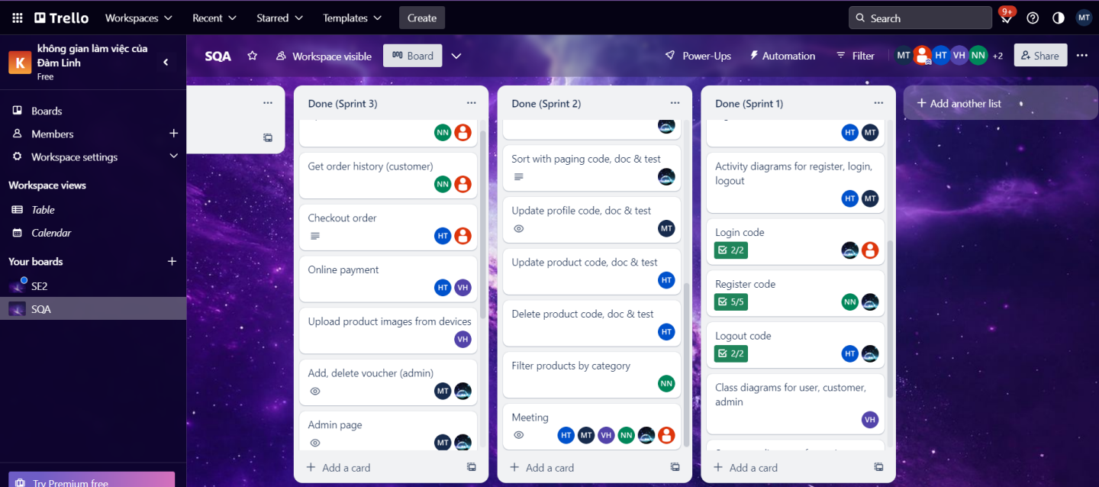

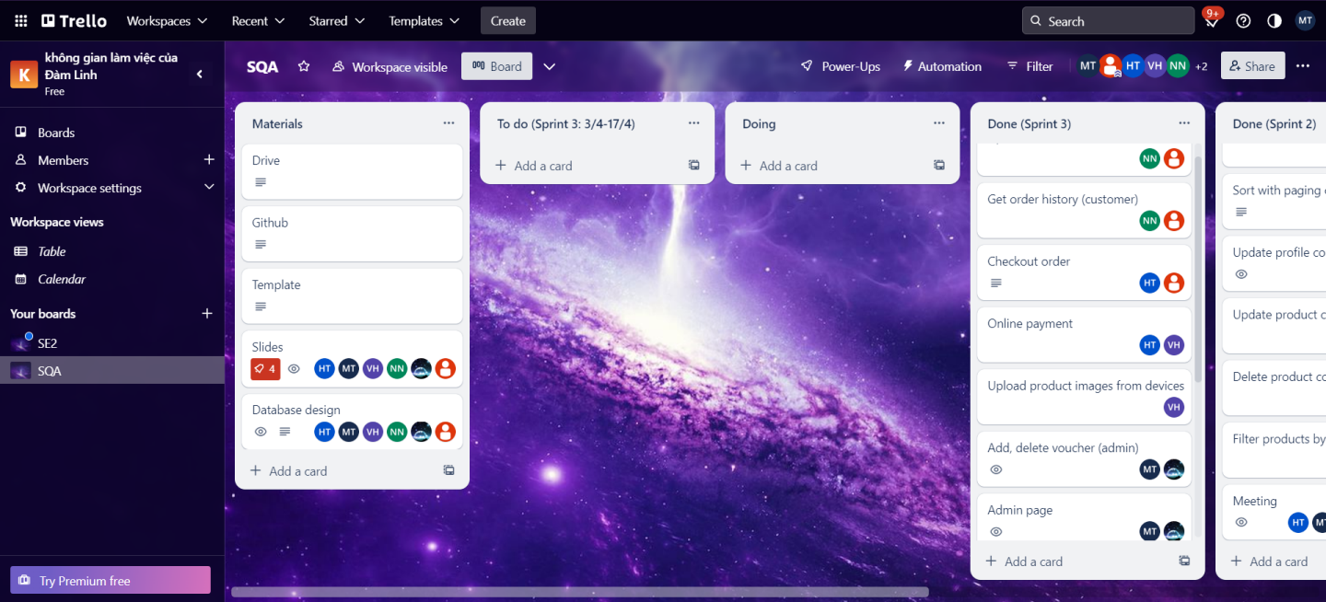

Architectures

**The Bookstore e-commerce Website project utilizes: Back-end: a combination of**

**Domain-Driven Design (DDD) architectures**

**Model-View-Controller (MVC) architectures**

**Front-end: Component-Based architecture**

**This approach significantly ensures a scalable, modular, and maintainable system.**

BE FE

Technologies 

Technologies

**Java Spring Boot: A Java-based framework that simplifies and accelerates the development of web applications by providing a convention-over-configuration approach, robust features, and seamless integration with other Spring components.**

**ReactJS: A JavaScript library for building responsive and interactive user interfaces, leveraging reusable components and a virtual DOM for efficient rendering.**

Main contents

**Introduction**

**Purposes**

**Project Framework**

**Project Summary**

**Strengths & WeaknessesConclusion**

Project Summary **1 2 3**

**Requirement**

**Use case diagrams Written use cases Activity diagrams ER Diagrams**

**Wireframes**

**Analysis & Design**

**System Architecture UI Design**

**Database Design Class Diagrams**

**Sequence Diagrams**

**Implementation**

**Source Code**

**Database Export**

**User Manuals**

**Administrator Manuals**

Project Summary **4 5**

**Testing**

**Testing plan Testing results**

**Deployment Deployment**

Requirements

Usecase diagram

Written Usecase *Example UC-1 / 22: Register*

Activity Diagram *Example UC-22 / 22: Pay by Paypal*

Entity

Relationship Diagram

Wireframe

*Example: Homepage wireframe*

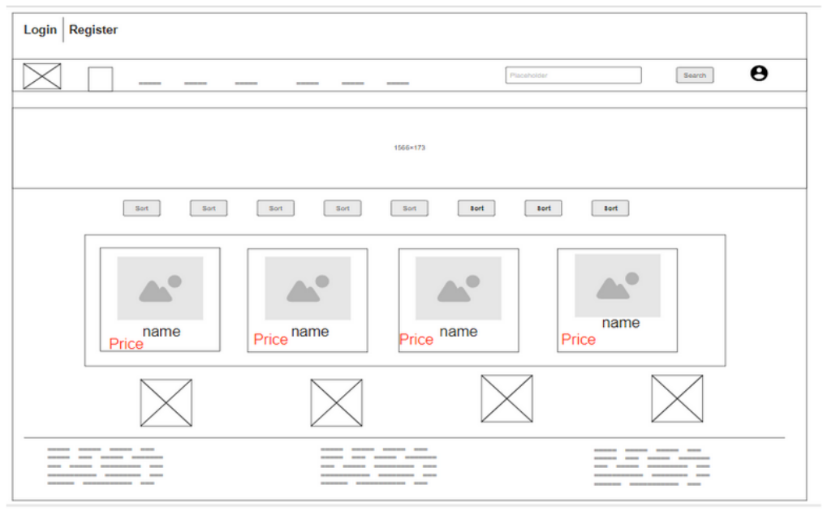

Analysis & Design

System Architectures Front-end Back-end

FE architecture

Component-based Architecture

**Component-based approach promotes reusability, modularity, and maintainability.**

**Components are self-contained and reusable units that can encapsulate a specific functionality or UI element, easily composed and combined to build complex UIs.**

FE architecture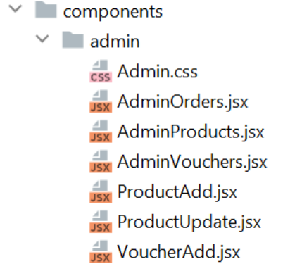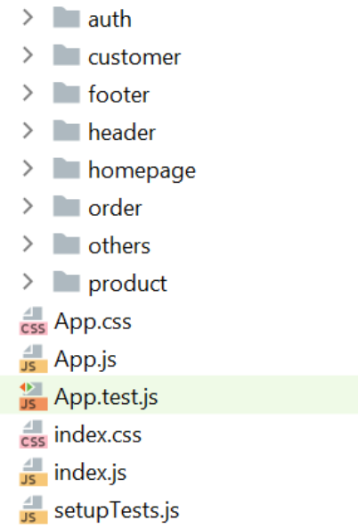

BE architectures

Model-View-Controller Architecture

**MVC provides a structured approach to separate concerns and organize the backend codebase.**

**Model: represents the domain models, encapsulating business logic and data persistence.**

**View: handles the presentation layer and user interface, providing a visually appealing and interactive experience for users.**

**Controller: acts as the intermediary between model and view, handling user requests, processing inputs, and coordinating the flow of data.**

BE architectures

Domain-Driven-Design Architecture

**DDD ensures the software design aligns with the business domain, enabling the development of complex systems that accurately meet the business requirements and logic.**

**Application layer: coordinates use cases, handling transactions, applying business rules, and mapping between the presentation and domain layers. Domain layer: encapsulates the core business logic, enforces business rules. Infrastructure layer: provides technical implementations and services, such as data persistence, data access, repositories, external API integrations, ...**

BE architectures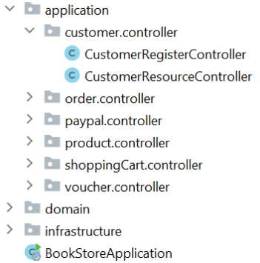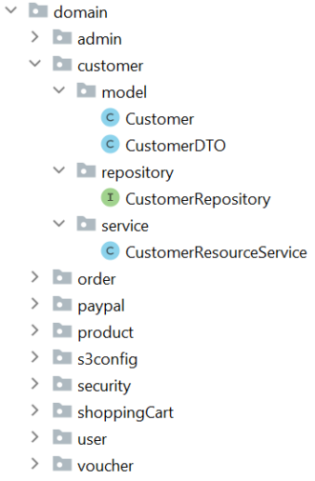

UI design

*Example: My shopping cart*

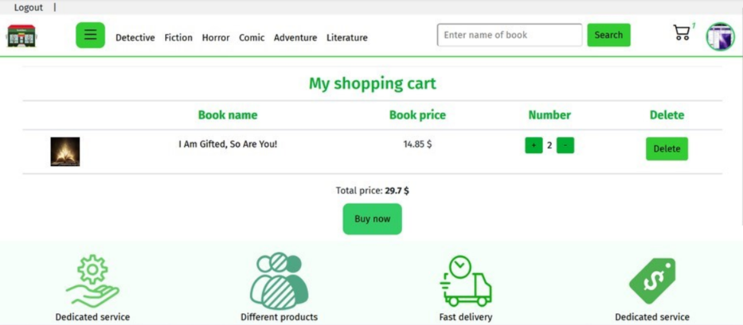

Database design

Class Diagram *Example UC-4 / 22: View home page with paging*

Sequence Diagram *Example UC-20 / 22: Add new voucher*

Implementation

Source code

https://github.com/Group9876



Customer & Admin manuals

https://docs.google.com/document/d/1Y

kWo6F4vk0ms9XsqAOkhHuQ_2EjA9j2Xv8

TcSBHUVn4/edit?usp=share_link

https://docs.google.com/document/d/1g

rVjSD2Uuk8Bfn0ZkrxzYDF56lvAbrjflPRtM5

QHlDY/edit?usp=share_link

***https://www.youtube.com/watch?v=Fo6gck0YV1I***

https://www.youtube.com/watch?v=Fo6gck0YV1I

Database Export

Testing

Testing Plan *Verification & Validation*

**1. Test Environment2. Test Types**

**4. Test Reporting 5. Risks & Mitigation**

**3. Test Approach 6. Sign-off**

Testing Result

*Example voucher manual test*

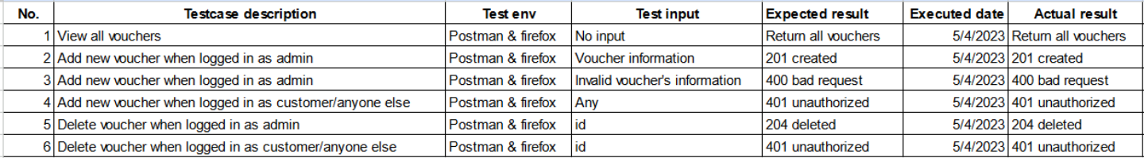

Deployment

Deployment

**https://bookstore-551a9.web.app**



Main contents

**Introduction**

**Purposes**

**Project Framework**

**Project Summary**

**Strengths & WeaknessesConclusion**

STRENGTHS

**Successful applications of Scrum methodology; DDD, MVC & Component-Based architectures; Java Spring Boot, ReactJS, MySQL, CSS. Reusability & Adaptability without changing code User-friendly Interface.**

**Quality Assurance**

**Efficient Search, Sort, Filter Functionality Authorization and Authentication**

**Seamless Checkout Process**

**Secure Payment**

**Order Tracking**

**Product, Voucher, Order Management Profile Modification**

WEAKNESSES

**Lack of Mobile responsiveness Lack of User Account Management Lack of Wishlist and Bookmarks Lack of Recommendation Function Lack of User Ratings and Reviews Lack of Shipping Management Challenges in performance optimization**

Main contents

**Introduction**

**Purposes**

**Project Framework**

**Project Summary**

**Strengths & WeaknessesConclusion**

Conclusion

**By prioritizing quality assurance, the project aims to build trust with customers, enhance user satisfaction, and establish a competitive edge in the online bookstore market**

**We highlighted the purposes, project frameworks, implementation, strengths and weaknesses of our project. The website will continue to addressing the identified weaknesses and leveraging the strengths to stay competitive in the online bookstore market.**

**We are confident that it will contribute to the growth of the bookstore business, attract a wide range of customers and provide a convenient platform for exploring and purchasing books online.**



Question Time